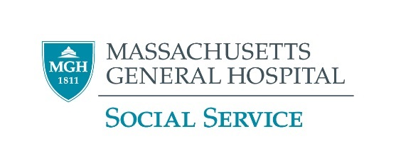

**MassHealth LICSW Registration Requirement**

There is a **ONE-TIME requirement** that you register with MassHealth as either a “billing” or “non-billing” provider. When the requirement was rolled out, the deadline for all LICSWs was 9/30/18; since that time it is now required when you apply for your LICSW.

**What are “Billing” Providers and “Non-Billing” providers?**

* **A NON-BILLING provider** is an LICSW who does not bill MassHealth directly for any client services.
  + **Staff who do not bill or only bill through the Department should register as non-billing providers.**
  + Registering as a non-billing provider does not prevent you from registering as a billing provider in the future.
  + **In MassHealth terminology a non-billing provider is called an “ordering, referring and prescribing” (ORP) provider** (you’ll see this on the application and contract.)
* **A BILLING provider** is a provider who is registered with MassHealth and is authorized to bill MassHealth directly for client services. LICSWs are only eligible to become QMB-Only Providers. If you have a private practice or otherwise bill MassHealth directly and you have not already registered, you may want to apply to become a QMB-Only/billing provider.

**How Do I Register?**

* **Non-Billing Providers** (you just work at MGH for example):
  1. **Obtain a MassHealth National Provider Identifier (NPI) number** if you do not already have one
     1. All LICSWs, including administrators, clinicians, case managers, discharge planners, etc., must obtain an NPI number before filling out and submitting their MassHealth NON-BILLING Provider Application and Contract. The NPI# application link is: <https://nppes.cms.hhs.gov/#/>
        1. You’ll need to register/create an account. **Instructions:** <https://nppes.cms.hhs.gov/assets/How_to_apply_for_an_NPI_online.pdf>
     2. Not sure if you have one? See the NPPES (the CMS National Plan and Provider Enumeration System) NPI Registry <https://npiregistry.cms.hhs.gov/>
  2. **Register as a NON-BILLING provider:**
     1. [Download the application and contract](https://www.mass.gov/doc/nonbilling-orp-provider-contract-and-application-3/download)**.**
     2. See more detailed instructions below.
* **Billing Providers:** (You have a private practice and have not yet registered for example.)Register as a QMB-Only Provider: Call the MassHealth Customer Service Center at 800-841-2900 to request an application.

**Additional Tips for the NON-BILLING (ORP) Provider Application and Contract**

* Make sure you complete the application and the contract with your same legal name.
* MassHealth will not accept the contract or application with any cross-outs.
* Note that this application is for all types of providers, not just for social workers, so some fields will not apply.
* **The Service Location MassHealth Provider ID:** **110001958F**.
* Answer “No” to the question “Is this service location a community health center, hospital outpatient clinic, hospital licensed health center, or Indian Health Service AND contracted with MassHealth as a PCC Plan site?”
* **The disclosure section 2A is for business owners only.** Unless you own a private practice that employs other people (including a billing person or company) check “none”.
* **DO complete the section 2B disclosures.**
* While you do need to include your home address, we’ve been assured this will not be made public due to this registration.
* **Fax:** (617) 988-8974 or mail to: Provider Enrollment and Credentialing PO Box 278 Quincy, MA 02171-0278

**More Information**

* **MassHealth- for NON-billing providers:** <https://www.mass.gov/how-to/how-to-enroll-to-be-a-masshealth-orp-provider> (ORP stands for “ordering, referring and prescribing,” which is the category of activities that non-billing providers are able to do.  O&R stands for “ordering and referring.” These terms are synonymous with “non-billing provider.”)